1. DATA TRANSMISSION AND TYPES OF NOISE IN COMMUNICATION SYSTEMS

1.1 Overview

A telecommunication system basically consists of three parts. At one end is the transmitter. The transmitter accepts information from a source, transforms it into a form that can be transmitted and sends it over a channel. The channel possibly distorts the transmitted signal before it reaches the receiver. It is then the receivers job to figure out what signal was transmitted, and to turn it into understandable information. If everything goes well, the information the receiver delivers should coincide with the information fed into the transmitter as shown in Figure 1.1.
Transmitter
Channel
Receiver

Figure 1.1 Basic Components of a Transmission System.

Digital communication differs from its analogue counterpart in that it can only transmit a finite number of waveforms. The information to be transmitted is typically a stream of binary digits. The information reaching the transmitter is typically coded, i.e. redundant bits have been added to the message to provide protection against transmission errors. In the same way, the information that leaves the receiver must be decoded before it can be used. Neither encoding nor decoding will be discussed further, and the digital communication systems.

Noise can be defined as an unwanted signal that interferes with the communication or measurement of another signal. A noise itself is a signal that conveys information regarding the source of the noise.

1.2 Structure of Communication System

Electrical communication system is designed to send messages or information from a source that generates the messages to one or two destinations. In general, a communication system can be represented by the functional block diagram shown in Figure 1.2.

The information generated by the source may be of the form of voice (speech source), a picture (image source), or plain text in some particular language, such as English, Japanese, German, French, etc. An essential feature of any source that generates information is that its output is described in probabilistic terms; that is, the output of a source is not deterministic. Otherwise, there would be no need to transmit the message.

Information
Source and
Input transducer

Transmitter

Channel

Receiver
Output
transducer
Output Signal

Figure 1.2 Functional block diagram of a communication system.

A transducer is usually required to convert the output of a source into an electrical signal that is suitable for transmission. For example, a microphone serves as the transducer that converts an acoustic speech signal into an electrical signal, and a video camera converts an image into an electrical signal. At the destination, a similar transducer is required to convert the electrical signals that are received into a form that is suitable for the user; for example, acoustic signals, images, etc.
The heart of the communication system consists of three basic parts, namely, the transmitter, the channel, and the receiver. The functions performed by these three elements are described below.

1.2.1 The Transmitter
The transmitter converts the electrical signal into a form that is suitable for transmission through the physical channel or transmission medium. For example, in radio and TV broadcast, the Federal Communications Commission (FCC) specifies the frequency range for each transmitting station. Hence, the transmitter must translate the information signal to be transmitted into the appropriate frequency range that matches the frequency allocation assigned to the transmitter. Thus, signals transmitted by multiple radio stations do not interfere with one another. Similar functions are performed in telephone communication systems, where the electrical speech signals from many users are transmitted over the same wire.

In general, the transmitter performs the matching of the message signal to the channel by a process called modulation. Usually, modulation involves the use of the information signal to systematically vary the amplitude, frequency, or phase of a sinusoidal carrier. For example, in AM radio broadcast, the information signal that is transmitted is contained in the amplitude variations of the sinusoidal carrier, which is the center frequency in the frequency band allocated to the radio transmitting station. This is an example of amplitude modulation. In FM radio broadcast, the information signal that is transmitted is contained in the frequency variations of the sinusoidal carrier. This is an example of frequency modulation. Phase modulation (PM) is yet a third method for impressing the information signal on a sinusoidal carrier.

In general, carrier modulation such as AM, FM, and PM is performed at the transmitter, as indicated above, to convert the information signal to a form that matches the characteristic of the channel. Thus, through the process of modulation, the information signal is translated in frequency to match the allocation of the channel. The choice of the type of modulation is based on several factors, such as the amount of bandwidth allocated, the types of noise and interference that the signal encounters in transmission over the channel, and the electronic devices that are available for signal amplification prior to transmission. In any case, the modulation process makes it possible to accommodate the transmission of multiple messages from many users over the same physical channel.

In addition to modulation, other functions that are usually performed at the transmitter are filtering of the information-bearing signal, amplification of the modulated signal, and in the case of wireless transmission, radiation of the signal by means of a transmitting antenna.

1.2.2 The Channel
The communications channel is the physical medium that is used to send the signal from the transmitter to the receiver. In wireless transmission, the channel is usually the atmosphere (free space). On the other hand, telephone channels usually employ a variety of physical media, including wire lines, optical fiber cables, and wireless (microwave radio). Whatever the physical medium for signal transmission, the essential feature is that the transmitted signal is corrupted in a random manner by a variety of possible mechanisms. The most common form of signal degradation comes in the form of additive noise, which is generated at the front end of the receiver, where signal amplification is performed. This noise is often called thermal noise. In wireless transmission, additional additive disturbances are man-made noise and atmospheric noise picked up by a receiving antenna. Automobile ignition noise is an example of man-made noise, and electrical lightning discharges from thunderstorms is an example of atmospheric noise. Interference from other users of the channel is another form of additive noise that often arises in both wireless and wire line communication systems.

In some radio communication channels, such as the ionospheric channel that is used for long-range, short-wave radio transmission, another form of signal degradation is multipath propagation. Such signal distortion is characterized as a no additive signal disturbance, which manifests itself as time variations in the signal amplitude, usually called fading.

Both additive and nor additive signal distortions are usually characterized as random phenomena and described in statistical terms. The effect of these signal distortions must be taken into account in the design of the communication system.

In the design of a communication system, the system designer works with mathematical models that statistically characterize the signal distortion encountered on physical channels. Often, the statistical description that is used in a mathematical model is a result of actual empirical measurements obtained from experiments involving signal transmission over such channels. In such case, there is a physical justification for the mathematical model used in the design of communication systems. On the other hand, in some communication system designs, the statistical characteristics of the channel may vary significantly with time. In such cases, the system designer may design a communication system that is robust to the variety of signal distortions. This can be accomplished by having the system adapt some of its parameters to the channel distortion encountered.

1.2.3 The Receiver

The function of the receiver is to recover the message signal contained in the received signal. If the message signal is transmitted by carrier modulation, the receiver performs carrier demodulation to extract the message from the sinusoidal carrier. Since the signal demodulation is performed in the presence of additive noise and possibly other signal distortion, the demodulated message signal is generally degraded to some extent by the presence of these distortions in the received signal. As we shall see, the fidelity of the received message signal is a function of the type of modulation, the strength of the additive noise, the type and strength of any other additive interference, and the type of any no additive interference.
Besides performing the primary function of signal demodulation, the receiver also performs a number of peripheral functions, including signal filtering and noise suppression.

1.3 Channel Distortions

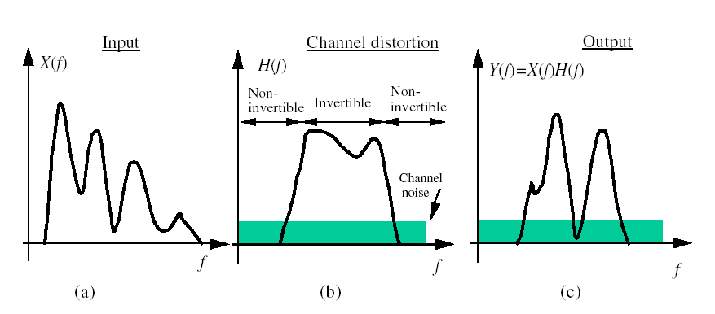
On propagating through a channel, signals are shaped and distorted by the frequency response and the attenuating characteristics of the channel. There are two main manifestations of channel distortions: magnitude distortion and phase distortion. In addition, in radio communication, we have the multi-path effect, in which the transmitted signal may take several different routes to the receiver, with the effect that multiple versions of the signal with different delay and attenuation arrive at the receiver. Channel distortions can degrade or even severely disrupt a communication process, and hence channel modeling and equalization are essential components of modern digital communication systems. Channel equalization is particularly important in modern cellular communication systems, since the variations of channel characteristics and propagation attenuation in cellular radio systems are far greater than those of the landline systems. Figure 1.3 illustrates the frequency response of a channel with one invertible and two non-invertible regions. In the non-invertible regions, the signal frequencies are heavily attenuated and lost to the channel noise. In the invertible region, the signal is distorted but recoverable. This example illustrates that the channel inverse filter must be implemented with care in order to avoid undesirable results such as noise amplification at frequencies with a low SNR.

Figure 1.3 Illustration of channel distortion: (a) the input signal spectrum, (b) the channel frequency response, (c) the channel output.

1.4 Channel Noise

Noise may be defined as any unwanted signal that interferes with the communication, measurement or processing of an information-bearing signal. Noise is present in various degrees in almost all environments. For example, in a digital cellular mobile telephone system, there may be several variety of noise that could degrade the quality of communication, such as acoustic background noise, thermal noise, electromagnetic radio-frequency noise, co-channel interference, radio-channel distortion, echo and processing noise. Noise can cause transmission errors and may even disrupt a communication process; hence noise processing is an important part of modern telecommunication and signal processing systems. The success of a noise processing method depends on its ability to characterize and model the noise process, and to use the noise characteristics advantageously to differentiate the signal from the noise. Depending on its source, a noise can be classified into a number of categories, indicating the broad physical nature of the noise, as follows:
a. Acoustic noise: emanates from moving, vibrating, or colliding sources and is the most familiar type of noise present in various degrees in everyday environments. Acoustic noise is generated by such sources as moving cars, air-conditioners, computer fans, traffic, people talking in the background, wind, rain, etc.
b. Electromagnetic noise: present at all frequencies and in particular at the radio frequencies. All electric devices, such as radio and television transmitters and receivers, generate electromagnetic noise.
c. Electrostatic noise: generated by the presence of a voltage with or without current flow. Fluorescent lighting is one of the more common sources of electrostatic noise.
d. Channel distortions, echo, and fading: due to non-ideal characteristics of communication channels. Radio channels, such as those at microwave frequencies used by cellular mobile phone operators, are particularly sensitive to the propagation characteristics of the channel environment.
e. Processing noise: the noise that results from the digital/analog processing of signals, e.g. quantization noise in digital coding of speech or image signals, or lost data packets in digital data communication systems.

Depending on its frequency or time characteristics, a noise process can be classified into one of several categories as follows:
a. Narrowband noise: a noise process with a narrow bandwidth such as a 50/60 Hz ‘hum’ from the electricity supply.
b. White noise: purely random noise that has a flat power spectrum. White noise theoretically contains all frequencies in equal intensity.
c. Band-limited white noise: a noise with a flat spectrum and a limited bandwidth that usually covers the limited spectrum of the device or the signal of interest.
d. Colored noise: non-white noise or any wideband noise whose spectrum has a non-flat shape; examples are pink noise, brown noise and autoregressive noise.
e. Impulsive noise: consists of short-duration pulses of random amplitude and random duration.
f. Transient noise pulses: consists of relatively long duration noise pulses.

1.4.1 White Noise

White noise is defined as an uncorrelated noise process with equal power at all frequencies (Figure 1.4). A noise that has the same power at all frequencies in the range of (±∞)   would necessarily need to have infinite power, and is therefore only a theoretical concept. However a band-limited noise process, with a flat spectrum covering the frequency range of a band-limited communication system, is to all intents and purposes from the point of view of the system a white noise process. For example, for an audio system with a bandwidth of 10 kHz, any flat-spectrum audio noise with a bandwidth greater than 10 kHz looks like a white noise.

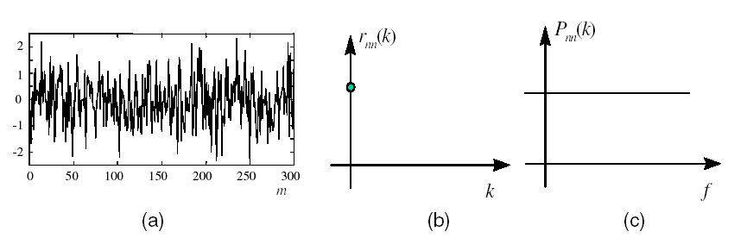

Figure 1.4 Illustration of (a) white noise, (b) its autocorrelation, and
(c) its power spectrum.

The autocorrelation function of a continuous-time zero-mean white noise process with a variance of $σ^{2}$is a delta function given by

(1.1)

The power spectrum of a white noise, obtained by taking the Fourier transform of Equation (1.2), is given by
(1.2)
Equation (1.3) shows that a white noise has a constant power spectrum. A pure white noise is a theoretical concept, since it would need to have infinite power to cover an infinite range of frequencies. Furthermore, a discrete-time signal by necessity has to be band-limited, with its highest frequency less than half the sampling rate. A more practical concept is band-limited white noise, defined as a noise with a flat spectrum in a limited bandwidth. The spectrum of band-limited white noise with a bandwidth of B Hz is given by
(1.3)
Thus the total power of a band-limited white noise process is 2B$σ^{2}$ The autocorrelation function of a discrete-time band-limited white noise process is given by
(1.4)
where T_{s} is the sampling period. For convenience of notation Ts is usually assumed to be unity. For the case when T_{s}=1/2B, i.e. when the sampling rate is equal to the Nyquist rate, Equation (1.4) becomes
(1.5)
In Equation (1.5) the autocorrelation function is a delta function.

1.4.2 Colored Noise

Although the concept of white noise provides a reasonably realistic and mathematically convenient and useful approximation to some predominant noise processes encountered in telecommunication systems, many other noise processes are non-white. The term colored noise refers to any broadband noise with a non-white spectrum. For example most audio frequency noise, such as the noise from moving cars, noise from computer fans, electric drill noise and people talking in the background, has a nonwhite predominantly low-frequency spectrum. Also, a white noise passing through a channel is “colored” by the shape of the channel spectrum. Two classic varieties of colored noise are so-called pink noise and brown noise, shown in Figures 1.5 and 1.6.
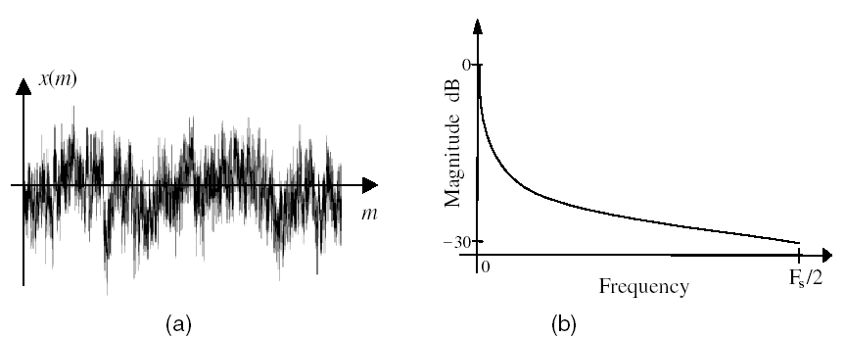

Figure 1.5 (a) A pink noise signal and (b) its magnitude spectrum.

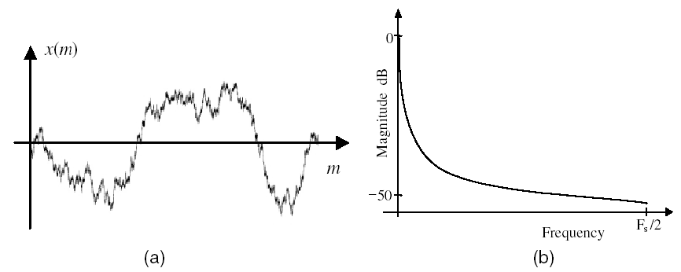

Figure 1.6 (a) A brown noise signal and (b) its magnitude spectrum.

1.4.3 Impulsive Noise

Impulsive noise consists of short-duration “on/off” noise pulses, caused by a variety of sources, such as switching noise, adverse channel environment in a communication system, drop-outs or surface degradation of audio recordings, clicks from computer keyboards, etc. Figure 1.7(a) shows an ideal impulse and its frequency spectrum. In communication systems, a real impulsive-type noise has a duration that is normally more than one sample long. For example, in the context of audio signals, short-duration, sharp pulses, of up to 3 milliseconds (60 samples at a 20 kHz sampling rate) may be considered as impulsive noise. Figures 1.7(b) and (c) illustrate two examples of short-duration pulses and their respective spectra. In a communication system, an impulsive noise originates at some point in time and space, and then propagates through the channel to the receiver. The received noise is time-dispersed and shaped by the channel, and can be considered as the channel impulse response (Figure 1.8). In general, the characteristics of a communication channel may be linear or non-linear, stationary or time varying.

Furthermore, many communication systems, in response to a large amplitude impulse, exhibit a non-linear characteristic.
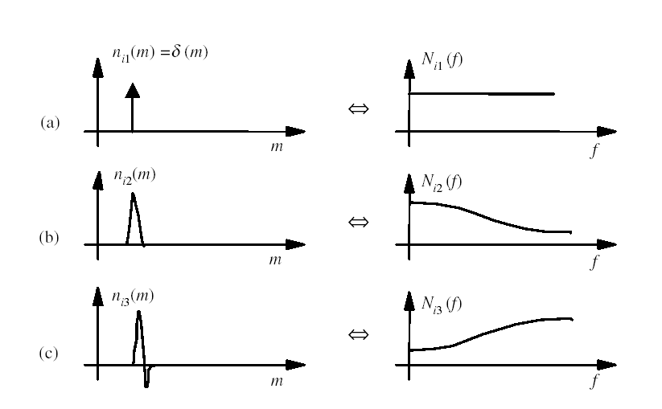

Figure 1.7 Time and frequency sketches of: (a) an ideal impulse, (b) and (c) short duration pulses.

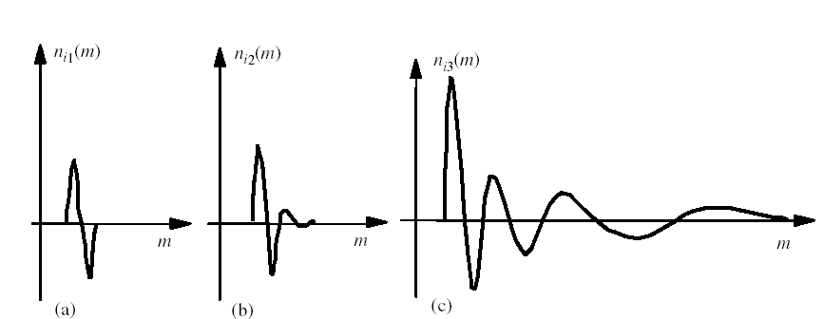

Figure 1.8 Illustration of variations of the impulse response of a non-linear system with the increasing amplitude of the impulse.

Figure 1.8 illustrates some examples of impulsive noise, typical of those observed on an old gramophone recording. In this case, the communication channel is the playback system, and may be assumed to be time-invariant. The figure also shows some variations of the channel characteristics with the amplitude of impulsive noise. For example, in Figure 1.7(c) a large impulse excitation has generated a decaying transient pulse. These variations may be attributed to the non-linear characteristics of the playback mechanism.

1.4.4 Transient Noise Pulses

Transient noise pulses often consist of a relatively short sharp initial pulse followed by decaying low-frequency oscillations as shown in Figure 1.9. The initial pulse is usually due to some external or internal impulsive interference, where as the oscillations are often due to the resonance of the averaged profile of a gramophone record scratch pulse.
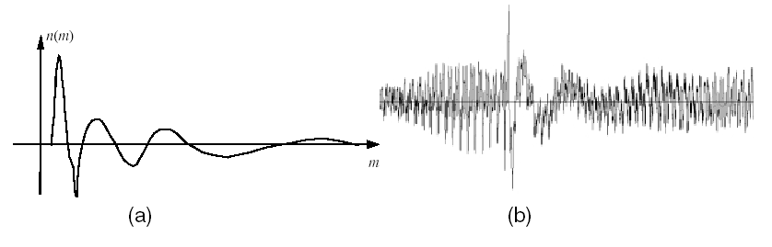

Figure 1.9 (a) A scratch pulse and (b) music from a gramophone record.

The communication channel excited by the initial pulse, and may be considered as the response of the channel to the initial pulse. In a telecommunication system, a noise pulse originates at some point in time and space, and then propagates through the channel to the receiver. The noise pulse is shaped by the channel characteristics, and may be considered as the channel pulse response. Thus we should be able to characterize the transient noise pulses with a similar degree of consistency as in characterizing the channels through which the pulses propagate. As an illustration of the shape of a transient noise pulse, consider the scratch pulses from a damaged gramophone record shown in Figures 1.9(a) and (b). Scratch noise pulses are acoustic manifestations of the response of the stylus and the associated electro-mechanical playback system to a sharp physical discontinuity on the recording medium. Since scratches are essentially the impulse response of the playback mechanism, it is expected that for a given system, various scratch pulses exhibit a similar characteristics. As shown in Figure 1.9(b), a typical scratch pulse waveform often exhibits two distinct regions:
(a) The initial high-amplitude pulse response of the playback system to the physical discontinuity on the record medium, followed by;
(b) Decaying oscillations that cause additive distortion. The initial pulse is relatively short and has duration on the order of 1–5 ms, whereas the oscillatory tail has a longer duration and may last up to 50 ms or more.

Note in Figure 1.9(b) that the frequency of the decaying oscillations decrease with time. This behavior may be attributed to the non-linear modes of response of the electro-mechanical playback system excited by the physical scratch discontinuity. Observations of many scratch waveforms from damaged gramophone records reveals that they have a well-defined profile, and can be characterized by a relatively small number of typical templates.

1.4.5 Thermal Noise

Thermal noise, also referred to as Johnson noise, is generated by the random movements of thermally energized particles. The concept of thermal noise has its roots in thermodynamics and is associated with the temperature-dependent random movements of free particles such as gas molecules in a container or electrons in a conductor. Although these random particle movements average to zero, the fluctuations about the average constitute the thermal noise. For example, the random movements and collisions of gas molecules in a confined space produce random fluctuations about the average pressure. As the temperature increases, the kinetic energy of the molecules and the thermal noise increase.

Similarly, an electrical conductor contains a very large number of free electrons, together with ions that vibrate randomly about their equilibrium positions and resist the movement of the electrons. The free movement of electrons constitutes random spontaneous currents, or thermal noise, that average to zero since in the absent of a voltage electrons move in all different directions. As the temperature of a conductor, provided by its surroundings, increases, the electrons move to higher-energy states and the random current flow increases. For a metallic resistor, the mean square value of the instantaneous voltage due to the thermal noise is given by
(1.6)
where k=1.38×10^{–23} joules per degree Kelvin is the Boltzmann constant, T is the absolute temperature in degrees Kelvin, R is the resistance in ohms and B is the bandwidth. From Equation (1.6) and the preceding argument, a metallic resistor sitting on a table can be considered as a generator of thermal noise power, with a mean square voltage 2 v and an internal resistance R. From circuit theory, the maximum available power delivered by a “thermal noise generator”, dissipated in a matched load of resistance R, is given by
(1.7)
where V_{rms} is the root mean square voltage. The spectral density of thermal noise is given by
(1.8)
From Equation (1.8), the thermal noise spectral density has a flat shape, i.e. thermal noise is a white noise. Equation (1.8) holds well up to very high radio frequencies of 10¹³ Hz.

1.4.6 Shot Noise

The term shot noise arose from the analysis of random variations in the emission of electrons from the cathode of a vacuum tube. Discrete electron particles in a current flow arrive at random times, and therefore there will be fluctuations about the average particle flow. The fluctuation in the rate of particle flow constitutes the shot noise. Other instances of shot noise are the flow of photons in a laser beam, the flow and recombination of electrons and holes in semiconductors, and the flow of photo electrons emitted in photo diodes. The concept of randomness of the rate of emission or arrival of particles implies that shot noise can be modeled by a Poisson distribution. When the average number of arrivals during the observing time is large, the fluctuations will approach a Gaussian distribution. Note that where as thermal noise is due to “unforced” random movement of particles, shot noise happens in a forced directional flow of particles. Now consider an electric current as the flow of discrete electric charges. If the charges act independently of each other the fluctuating current is given by

(1.9)
Equation (1.9) assumes that the charge carriers making up the current act independently. That is the case for charges crossing a barrier, as for example the current in a junction diode, where the charges move by diffusion; but it is not true for metallic conductors, where there are long-range correlations between charge carriers.

1.4.7 Electromagnetic Noise

Virtually every electrical device that generates, consumes or transmits power is a potential source of electromagnetic noise and interference for other systems. In general, the higher the voltage or the current level, and the closer the proximity of electrical circuits/devices, the greater will be the induced noise. The common sources of electromagnetic noise are transformers, radio and television transmitters, mobile phones, microwave transmitters, ac power lines, motors and motor starters, generators, relays, oscillators, fluorescent lamps, and electrical storms. Electrical noise from these sources can be categorized into two basic types: electrostatic and magnetic. These two types of noise are fundamentally different, and thus require different noise-shielding measures. Unfortunately, most of the common noise sources listed above produce combinations of the two noise types, which can complicate the noise reduction problem.

Electrostatic fields are generated by the presence of voltage, with or without current flow. Fluorescent lighting is one of the more common sources of electrostatic noise. Magnetic fields are created either by the flow of electric current or by the presence of permanent magnetism. Motors and transformers are examples of the former, and the Earth's magnetic field is an instance of the latter. In order for noise voltage to be developed in a conductor, magnetic lines of flux must be cut by the conductor. Electric generators function on this basic principle. In the presence of an alternating field, such as that surrounding a 50/60 Hz power line, voltage will be induced into any stationary conductor as the magnetic field expands and collapses. Similarly, a conductor moving through the Earth's magnetic field has a noise voltage generated in it as it cuts the lines of flux.

1.5 The Interface of a Digital Communication System

The data that is to be transmitted in digital communication systems are typically bits. In the transmitter, these binary digits are divided into groups and each group of bits is mapped into a so-called symbol. A symbol is a real or complex number.
Every discrete symbol is transformed into a continuous-time signal by a generalized form of DA-conversion known as pulse shaping, which is depicted in Figure 1.10. In its simplest form, pulse shaping is accomplished by using a zero-order-hold DA converter, which will result in a rectangular pulse shape.

However, more intelligent design of the pulse shaping filter improves the spectral efficiency of the continuous-time signal.

P(t)

Figure 1.10 Pulse shaping with the pulse shaping filter. In this example, the resulting pulse shape is a so-called raised cosine pulse.

The continuous-time signal is called a baseband signal. Its spectrum is depicted in Figure 1.11. The base band signal has a symmetric spectrum around the center frequency f=0 if and only if the symbols are real. This is a well known fact from complex analysis: only real signals have a spectrum that is symmetric with respect to f=0.

x
y

Figure 1.11 The spectrum of the baseband signal. The spectrum is symmetric around f=0 if and only if the symbols are real.

1.6 Summary

The discussion of noise, channel characteristics, inter-symbol interferences and the equalization problem of channel distortion have been taken into consideration in this chapter. In addition, the effects of each and how they present in the system had been described.

